**Lab Practical #02:**

Study of different types of network cables & connectors and crimping a LAN.

**Practical Assignment #02:**

1. List various networks cable. Also, write short description.
2. Difference between guided and unguided media.
3. Give cross-wired cable and straight through cable diagram (Color Code wise).

## List various networks cable and connectors. Also, write short description.

1. **Network Cable Name: Twisted Pair Cable**
   * **Description**: Twisted pair is the ordinary copper wire that connects home and business computers to the telephone company. To reduce crosstalk or electromagnetic induction between pairs of wires, two insulated copper wires are twisted around each other. Each connection on twisted pair requires both wires.
   * **Diagram**:
     1. **Shielded twisted pair cable :-**

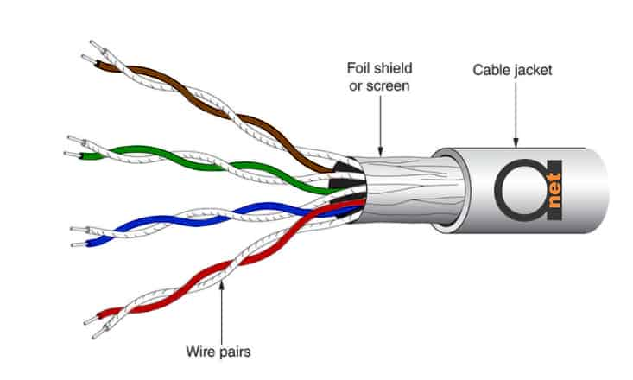

* + 1. **Unshielded twisted pair cable :-**

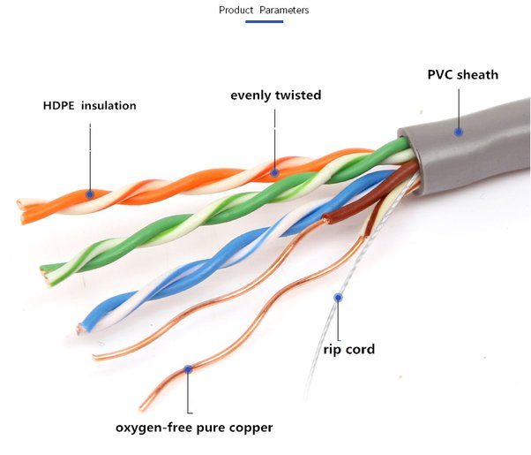

1. **Network Cable Name: Coaxial Cable**
   * **Description**: Coaxial cable is typically used by cable operators, telephone companies, and internet providers to transmit data, video, and voice communications to customers. Its installation and implementation are easy but it is less efficient than optical fiber also it provides moderately high bandwidth in comparison to optical fiber.
   * **Diagram**:

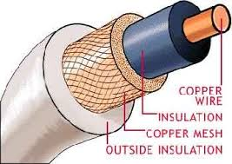

1. **Network Cable Name: Fiber-Optic cable**
   * **Description**: A fiber-optic cable contains anywhere from a few to hundreds of optical fibers within a plastic casing. Also known as optic cables or optical fiber cables, they transfer data signals in the form of light and travel hundreds of miles significantly faster than those used in traditional electrical cables.
   * **Diagram**:

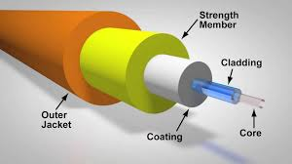

1. **Network Connectors :-** **RJ45 Connector**
   * **Description**: Used with twisted pair cables (both UTP and STP) for Ethernet networking. It has eight pins to connect the wires.
   * **Diagram**:

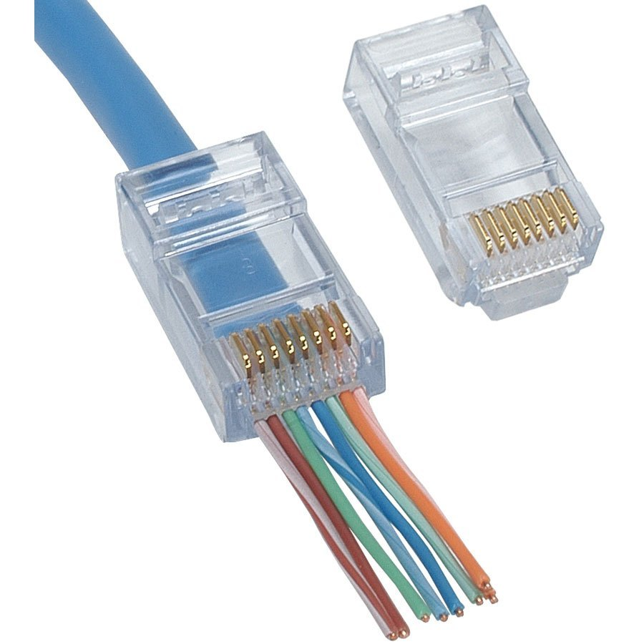

1. **Network Connectors :-** **USB Connector**
   * **Description**: Used with twisted pair cables (both UTP and STP) for Ethernet networking. It has eight pins to connect the wires.
   * **Diagram**:

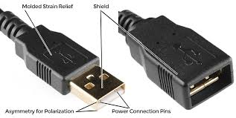

1. **Difference between guided and unguided media.**

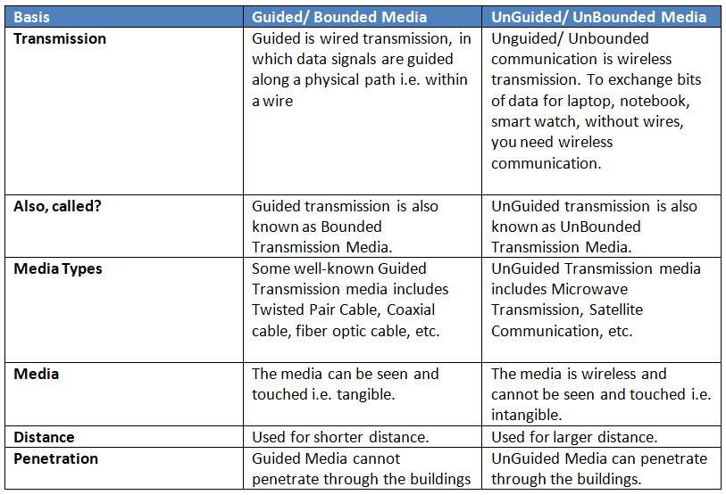

## Give cross-wired cable and straight through cable diagram (Color Code wise).

1. Cross-wired Cable Diagram (Color Code)

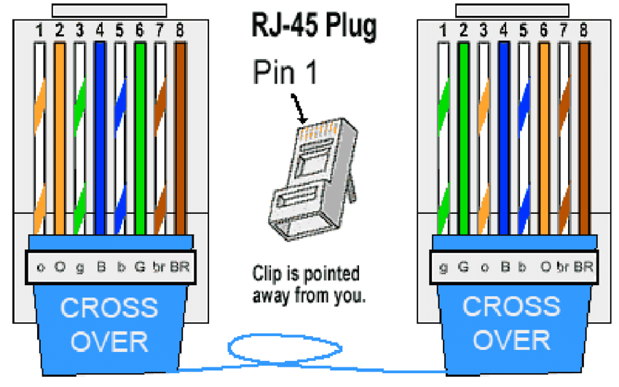

1. Straight Through Cable Diagram (Color Code)

